**Day 3**

Today

* Context in Android
* Activity lifecycle
* Configuration changes: orientation,
* Starting an activity for result
* Implicit and explicit intents
* The Bundle
* Serializable
* Parcelable
* Communicating between activities
* Implicit intents
* Back stack
* ShareActionProvider **(HW)**

*Half a page abut ShareActionProvider of how it works, and what objects, classes are necessary to use it.*

Activity Lifecycle

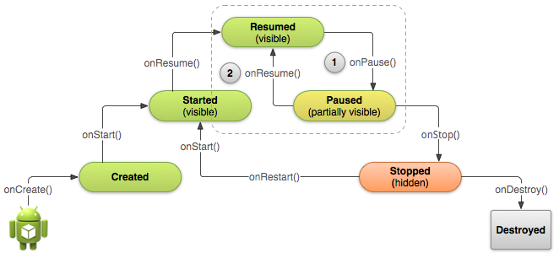

Configuration changes

* Configuration includes:

When you want to save a variable to the bundle

And then on save instance state read it and put it back into place

HOMEWORK

Looking at the context, questions are going to be made on Monday

Start activity for result, it’s homework but we are gonna do it here on Monday also

SUMMARY OF HOMEWORK

Save and restore savedinstancestate

Look for context

Do startactivityforresult

Parceable how to do and how to work with it

How to manipulate the backstack, wrote down methods, how to use it, when to use it, which methods to use

SharedActionProvider, create a project that uses the shareactionprovider and have it working

Make a project that’s interesting, go ahead and try that, surprise him

Create bundle object save and then read it for the savedinstancestate

Do exercise with parcelable

Backstack how do I modify it, change order,

Sharedpreferences